1. **Class Diagram**

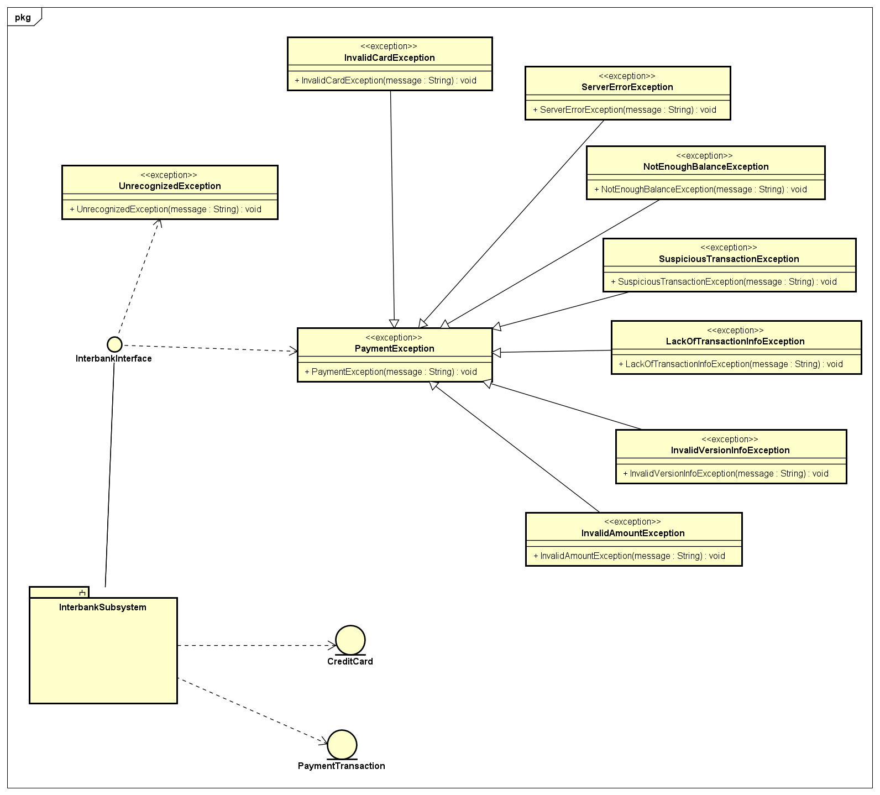

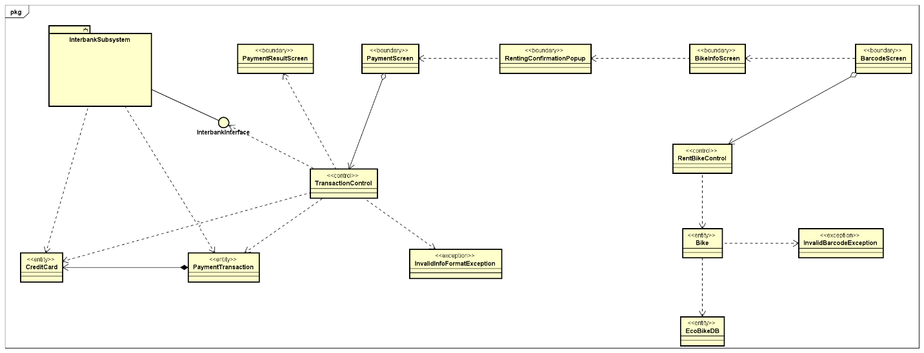

1. **Class Design**

***2.1 Request***

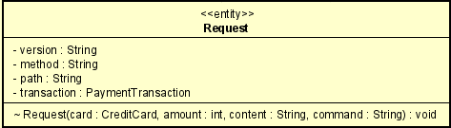

***Attribute***

|  |  |  |  |  |
| --- | --- | --- | --- | --- |
| *#* | *Name* | *Data type* | *Default value* | *Description* |
| 1 | version | String | 1.0.1 | Version use to request Interbank |
| 2 | method | String | PATCH | Method use to request Interbank |
| 3 | path | String | NULL | Path to request Interbank |
| 4 | transaction | PaymentTransaction | NULL | The payment transaction to request Interbank |

***Operation***

|  |  |  |
| --- | --- | --- |
| *#* | *Name* | *Description (purpose)* |
| 1 | Request | Constructor for class Request |

*Parameter:*

* card – CreditCard used for the transaction
* amount – amount of money used for the transaction
* content – content of the transaction
* command – command for the Interbank (either “pay” or “refund”)

*Exception:*

* None

***Method***

None

***State***

None

***2.2 Response***

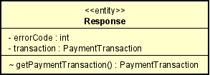

***Attribute***

|  |  |  |  |  |
| --- | --- | --- | --- | --- |
| *#* | *Name* | *Data type* | *Default value* | *Description* |
| 1 | errorCode | int | NULL | Describe the result of the transaction |
| 2 | transaction | PaymentTransaction | NULL | The transaction that was requested |

***Operation***

|  |  |  |  |
| --- | --- | --- | --- |
| *#* | *Name* | *Return type* | *Description (purpose)* |
| 1 | getPaymentTransaction | PaymentTransaction | To get the transaction that was requested |

*Parameter:*

* None

*Exception:*

* PaymentException if the transaction is fail and errorCode is recognized
* UnrecognizedException if the transaction is fail and the errorCode is unrecognizable

***Method***

None

***State***

None

***2.3 InterbankInterface***

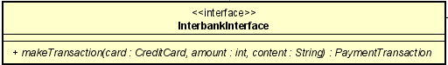

***Attribute***

None

***Operation***

|  |  |  |  |
| --- | --- | --- | --- |
| *#* | *Name* | *Return type* | *Description (purpose)* |
| 1 | makeTransaction | PaymentTransaction | Perform payment transaction |

*Parameter:*

* card – the credit card that was used for the transaction
* amount – the amount of money for transact
* content – the content of the transaction

*Exception:*

* PaymentException if the transaction is fail and errorCode is recognized
* UnrecognizedException if the transaction is fail and the errorCode is unrecognizable

***Method***

None

***State***

None

***2.4 InterbankBoundary***

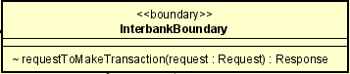

***Attribute***

None

***Operation***

|  |  |  |  |
| --- | --- | --- | --- |
| *#* | *Name* | *Return type* | *Description (purpose)* |
| 1 | requestToMakeTransaction | Response | Send the transaction request to Interbank |

*Parameter:*

* request – the transaction request that need to be send to Interbank

*Exception:*

* None

***Method***

None

***State***

None

***2.5 InterbankSubsystemControl***

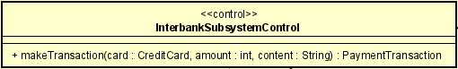

***Attribute***

None

***Operation***

|  |  |  |  |
| --- | --- | --- | --- |
| *#* | *Name* | *Return type* | *Description (purpose)* |
| 1 | makeTransaction | PaymentTransaction | Perform payment transaction |

*Parameter:*

* card – the CreditCard use for the transaction
* amount – amount for transaction (positive number to pay and negative number to refund)
* content – the content of the transaction

*Exception:*

* PaymentException if the transaction is fail and errorCode is recognized
* UnrecognizedException if the transaction is fail and the errorCode is unrecognizable

***Method***

None

***State***

None

***2.6 CreditCard***

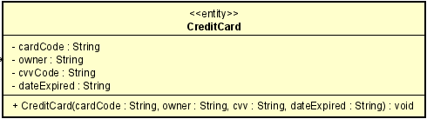

***Attribute***

|  |  |  |  |  |
| --- | --- | --- | --- | --- |
| *#* | *Name* | *Data type* | *Default value* | *Description* |
| 1 | cardCode | String | NULL | The code of the card |
| 2 | owner | String | NULL | The owner of the card |
| 3 | cvvCode | String | NULL | The security code of the card |
| 4 | dateExpired | String | NULL | The expired date of the card in the format of mmyy |

***Operation***

|  |  |  |
| --- | --- | --- |
| *#* | *Name* | *Description (purpose)* |
| 1 | CreditCard | The constructor for class CreditCard |

*Parameter:*

* cardCode – the code of the card
* owner – the owner of the card
* cvv – the security code of the card
* dateExpired – the expired date of the card in the format of mmyy

*Exception:*

* None

***Method***

None

***State***

None

***2.7 PaymentTransaction***

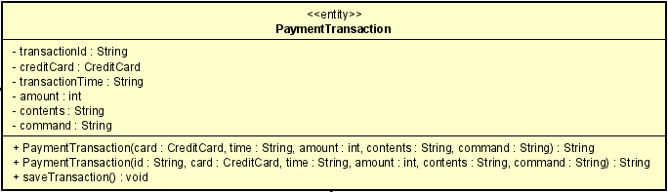

***Attribute***

|  |  |  |  |  |
| --- | --- | --- | --- | --- |
| *#* | *Name* | *Data type* | *Default value* | *Description* |
| 1 | transactionId | String | NULL | The unique identification of the transaction |
| 2 | creditCard | CreditCard | NULL | The credit card used for the transaction |
| 3 | transactionTime | String | NULL | The time the transaction was made |
| 4 | amount | int | NULL | The amount used for transaction |
| 5 | contents | String | NULL | The content of the transaction |
| 6 | command | String | NULL | The command that was used for the transaction |

***Operation***

|  |  |  |
| --- | --- | --- |
| *#* | *Name* | *Description (purpose)* |
| 1 | PaymentTransaction | The constructor for class PaymentTransaction using card, transaction time, amount of money in the transaction, transaction content and command used in the transaction |

*Parameter:*

* card – the credit card used for the transaction
* time – the time the transaction was made
* amount – the amount used for transaction
* contents – the content of the transaction
* command – the command used in the transaction (either “pay” or “refund”)

*Exception:*

* None

|  |  |  |
| --- | --- | --- |
| *#* | *Name* | *Description (purpose)* |
| 2 | PaymentTransaction | The constructor for class PaymentTransaction using transaction id, card, transaction time, amount of money in the transaction, transaction content and command used in the transaction |

*Parameter:*

* Id – the identification of the transaction
* card – the credit card used for the transaction
* time – the time the transaction was made
* amount – the amount used for transaction
* contents – the content of the transaction
* command – the command used in the transaction (either “pay” or “refund”)

*Exception:*

* None

***Method***

None

***State***

None

|  |  |  |  |
| --- | --- | --- | --- |
| *#* | *Name* | *Return type* | *Description (purpose)* |
| 3 | saveTransaction | void | Record the transaction into the database |

*Parameter:*

* None

*Exception:*

* None

***Method***

None

***State***

None

***2.8 TransactionControl***

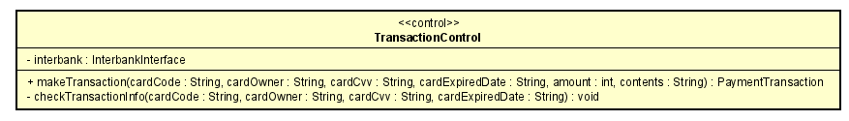

***Attribute***

|  |  |  |  |  |
| --- | --- | --- | --- | --- |
| *#* | *Name* | *Data type* | *Default value* | *Description* |
| 1 | interbank | InterbankInterface | New InterbankSubsystemControl() | Represent the interbank |

***Operation***

|  |  |  |  |
| --- | --- | --- | --- |
| *#* | *Name* | *Return type* | *Description (purpose)* |
| 1 | makeTransaction | PaymentTransaction | Perform payment transaction |

*Parameter:*

* cardCode – the code of the credit card used in the transaction
* cardOwner – the owner of the credit card used in the transaction
* cardCvv – the security code of the credit card used in the transaction
* cardExpiredDate – the expired date of the credit card used in the transaction
* amount – the amount of money in the transaction (positive to pay and negative to refund)
* contents – the contents of the transaction

*Exception:*

* PaymentException if the transaction fail and the error code is recognizable
* UnrecognizedException if the transaction fail and the error code is unrecognizable

***Method***

* checkTransactionInfo: use to check the format of the transaction info, if the transaction info is not in the correct format then throw InvalidInfoFormatException. The correct format should be: cardCode is a string of digits, cardOwner is a string of letter and not null, cardCvv contain exactly 3 digits, cardExpiredDate is in format of mmyy.

***State***

None

***2.9 PaymentScreen***

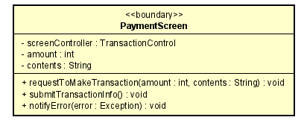

***Attribute***

|  |  |  |  |  |
| --- | --- | --- | --- | --- |
| *#* | *Name* | *Data type* | *Default value* | *Description* |
| 1 | screenController | TransactionControl | New TransactionControl() | The controller of the screen |
| 2 | amount | int | NULL | The amount of money in the payment transaction |
| 3 | contents | String | NULL | The contents of the payment transaction |

***Operation***

|  |  |  |  |
| --- | --- | --- | --- |
| *#* | *Name* | *Return type* | *Description (purpose)* |
| 1 | requestToMakeTransaction | void | Make this screen appear in order to make a payment transaction |

*Parameter:*

* amount – the amount of money use in the transaction (positive for pay and negative for refund)
* contents – the contents of the transaction

*Exception:*

* None

|  |  |  |  |
| --- | --- | --- | --- |
| *#* | *Name* | *Return type* | *Description (purpose)* |
| 2 | submitTransactionInfo | void | Submit the transaction info filled in the screen to the controller in order to make payment transaction |

*Parameter:*

* None

*Exception:*

* None

|  |  |  |  |
| --- | --- | --- | --- |
| *#* | *Name* | *Return type* | *Description (purpose)* |
| 3 | notifyError | void | Notify the user error in case an exception happen |

*Parameter:*

* error – The exception that need to inform user

*Exception:*

* None

***Method***

None

***State***

None

***2.10 PaymentResultScreen***

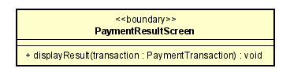

***Attribute***

None

***Operation***

|  |  |  |  |
| --- | --- | --- | --- |
| *#* | *Name* | *Return type* | *Description (purpose)* |
| 1 | displayResult | void | Display the succesful payment transaction with the transaction info |

*Parameter:*

* transaction – The transaction that was successfully finish

*Exception:*

* None

***2.11 BarcodeScreen***

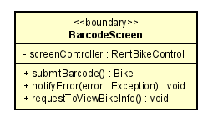

***Attribute***

|  |  |  |  |  |
| --- | --- | --- | --- | --- |
| *#* | *Name* | *Data type* | *Default value* | *Description* |
| 1 | screenController | RentBikeControl | New RentBikeControl() | The controller of the screen |

***Operation***

|  |  |  |  |
| --- | --- | --- | --- |
| *#* | *Name* | *Return type* | *Description (purpose)* |
| 1 | submitBarcode | Bike | Submit the barcode that the user input to the controller in order to get the corresponding bike |

*Parameter:*

* None

*Exception:*

* None

|  |  |  |  |
| --- | --- | --- | --- |
| *#* | *Name* | *Return type* | *Description (purpose)* |
| 2 | notifyError | void | Notify the user error in case an exception happen |

*Parameter:*

* error – The exception that need to inform user

*Exception:*

* None

|  |  |  |  |
| --- | --- | --- | --- |
| *#* | *Name* | *Return type* | *Description (purpose)* |
| 3 | requestToViewBike | void | Show the user the info of the bike with the correspond barcode |

*Parameter:*

* None

*Exception:*

* InvalidBarcodeException if there are no bike with the correspond barcode

***Method***

None

***State***

None

***2.12 BikeInfoScreen***

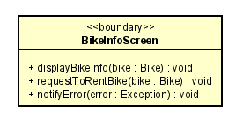

***Attribute***

None

***Operation***

|  |  |  |  |
| --- | --- | --- | --- |
| *#* | *Name* | *Return type* | *Description (purpose)* |
| 1 | displayBikeInfo | void | Show the information of a bike |

*Parameter:*

* bike – The bike that we want to show information

*Exception:*

* None

|  |  |  |  |
| --- | --- | --- | --- |
| *#* | *Name* | *Return type* | *Description (purpose)* |
| 2 | requestToRentBike | void | Process to rent a bike |

*Parameter:*

* bike – The bike you wish to rent

*Exception:*

* None

|  |  |  |  |
| --- | --- | --- | --- |
| *#* | *Name* | *Return type* | *Description (purpose)* |
| 3 | notifyError | void | Notify the user error in case an exception happen |

*Parameter:*

* error – The exception that need to inform user

*Exception:*

* None

***Method***

None

***State***

None

***2.13 Renting confirmation popup***

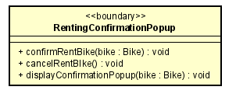

***Attribute***

None

***Operation***

|  |  |  |  |
| --- | --- | --- | --- |
| *#* | *Name* | *Return type* | *Description (purpose)* |
| 1 | confirmRentBike | void | Confirm to rent a bike |

*Parameter:*

* bike – The bike you wish to rent

*Exception:*

* None

|  |  |  |  |
| --- | --- | --- | --- |
| *#* | *Name* | *Return type* | *Description (purpose)* |
| 2 | cancelRentBike | void | Cancel the rent bike process |

*Parameter:*

* None

*Exception:*

* None

|  |  |  |  |
| --- | --- | --- | --- |
| *#* | *Name* | *Return type* | *Description (purpose)* |
| 3 | displayConfirmationPopup | void | Display this screen with the information of the bike you wish to rent |

*Parameter:*

* bike – The bike you wish to rent

*Exception:*

* None

***Method***

None

***State***

None

***2.14 RentBikeControl***

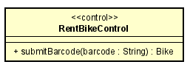

***Attribute***

None

***Operation***

|  |  |  |  |
| --- | --- | --- | --- |
| *#* | *Name* | *Return type* | *Description (purpose)* |
| 1 | submitBarcode | Bike | Take the barcode into the database to get the bike with that corresponding barcode |

*Parameter:*

* barcode - the barcode (identification) of the bike we would like to get from the database

*Exception:*

* InvalidBarcodeException if there no bike with the correspond barcode in the database

***Method***

None

***State***

None

***2.15 Bike***

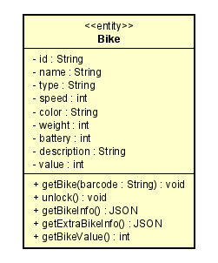

***Attribute***

|  |  |  |  |  |
| --- | --- | --- | --- | --- |
| *#* | *Name* | *Data type* | *Default value* | *Description* |
| 1 | id | String | NULL | // |
| 2 | name | String | NULL | // |
| 3 | type | String | NULL | // |
| 4 | speed | int | NULL | // |
| 5 | color | String | NULL | // |
| 6 | weight | int | NULL | // |
| 7 | battery | int | NULL | // |
| 8 | description | String | NULL | // |
| 9 | value | int | NULL | // |

***Operation***

|  |  |  |  |
| --- | --- | --- | --- |
| *#* | *Name* | *Return type* | *Description (purpose)* |
| 1 | getBike | void | Use the input barcode to change this class into the bike with that correspond barcode |

*Parameter:*

* barcode - the barcode (identification) of the bike we would like to change this object into

*Exception:*

* InvalidBarcodeException if no bike with that barcode was found in the database

|  |  |  |  |
| --- | --- | --- | --- |
| *#* | *Name* | *Return type* | *Description (purpose)* |
| 2 | unlock | void | Unlock this bike |

*Parameter:*

* None

*Exception:*

* None

|  |  |  |  |
| --- | --- | --- | --- |
| *#* | *Name* | *Return type* | *Description (purpose)* |
| 3 | getBikeInfo | JSON | Get the bike attributes |

*Parameter:*

* None

*Exception:*

* None

|  |  |  |  |
| --- | --- | --- | --- |
| *#* | *Name* | *Return type* | *Description (purpose)* |
| 4 | getExtraBikeInfo | JSON | Get EBike info, only work with EBike |

*Parameter:*

* None

*Exception:*

* NotEBikeException if bike is not EBike

|  |  |  |  |
| --- | --- | --- | --- |
| *#* | *Name* | *Return type* | *Description (purpose)* |
| 5 | getBikeValue | int | Get the bike value |

*Parameter:*

* None

*Exception:*

* None

***Method***

None

***State***

None

***2.16 EcoBikeDb***

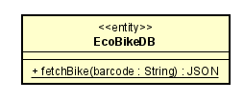

***Attribute***

None

***Operation***

|  |  |  |  |
| --- | --- | --- | --- |
| *#* | *Name* | *Return type* | *Description (purpose)* |
| 1 | fetchBike | JSON | Using barcode to get the corresponding bike information from the database |

*Parameter:*

* barcode – the barcode (identification) of the bike we would like to get from the database

*Exception:*

* InvalidBarcodeException if no bike with that barcode was found in the database

***Method***

None

***State***

None